Steven Haddad 217181454

Twin Telepathy

Summary of Project #1 Tabletop Game

Team Telepathy is a game that is a mix of Scrabble and Charades, where you work as a team to form words while under the pressure of a timer to gain points. But you need to be quick otherwise the opposing team can steal your word, and your points!

In the game teams are split into 2 teams of 2-4 people, the Actors and the Stealers, the goal of the Actors is to work together to place down tiles to form a word – that matches the theme of a randomly selected category card – before time runs out! The Stealers have a chance to complete the word once the time is up, awarding them points. Each round the teams switch roles and two rounds count as a set. The overarching goal of Team Telepathy is to win as many points as possible each round and come out with more total points than the other team at the end of the 5 sets.

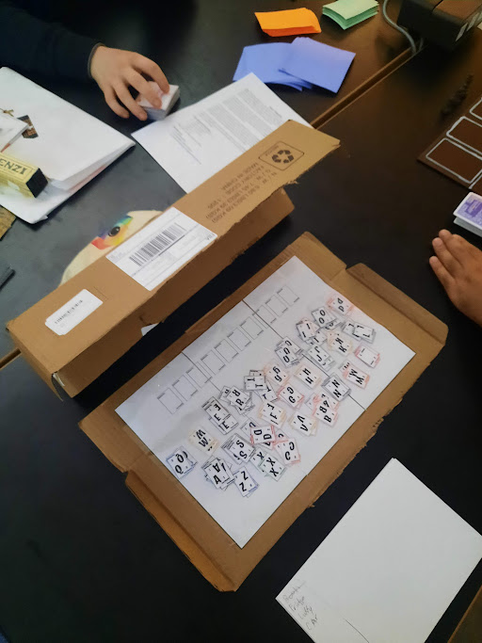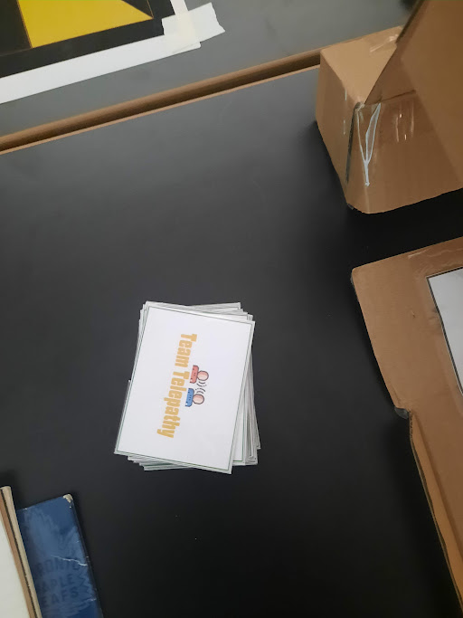

Alt Engine Adaptation

**Engine:** I chose GB Studio, because I wanted my game to have a top-down/isometric view, puzzle game and to me it seemed like the best engine to accomplish that. I’ve played game boy games like Pokemon and Metroid, and I was always fascinated with exploring and solving puzzles.

Summary of Project #2 Alt Engine

Originally, I wanted to adapt my game's mechanics of forming words with letters in order to try to make word puzzles. However that didn’t seem too feasible unless I made a keyboard. I didn't want my GB studio game to be a typing simulator so I decided to pivot to different kinds of puzzles.

I also wanted to make a game that made use of a mechanic where you can “summon a twin in one of the puzzles and you use “telepathy” to communicate with them, i.e you must control two characters at once. The controls of the twin and the original character will be intertwined, it won’t just be two sets of disjointed controls. This will be a core aspect of my game as it will be called Twin Telepathy.” While this seemed like a great idea in theory, for me it seemed like too much of a headache to implement. I decided to make it a game where you would need two players or twins to complete a puzzle, where one character was barred from entering one side of the level. 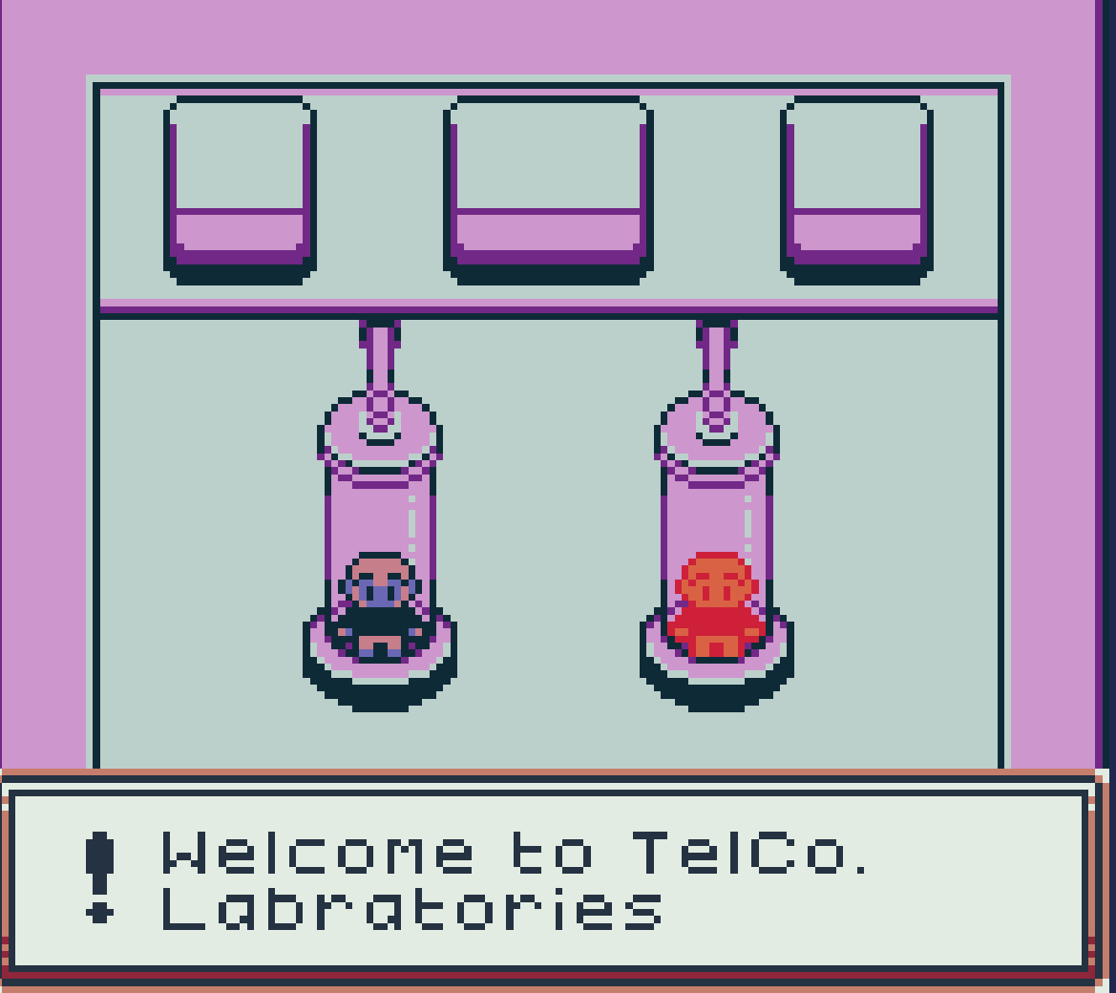

I didn't want to include a timer in my game, as I wanted it to be a slower paced puzzle game, and I didnt think a stealing element really fit in my game.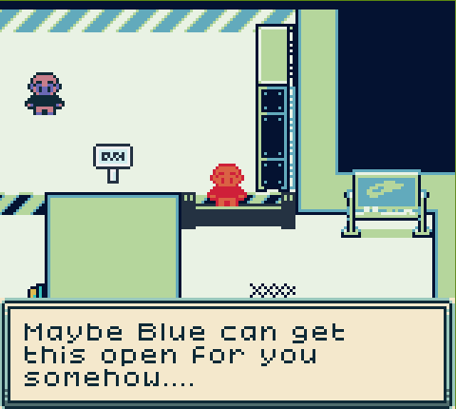

I ran into a lot of issues with trying to get my sprites to be a decent looking colour, I did not enjoy that at all. I also didn't really understand how the colour palettes worked until after I included my sprites, and there were some transparent parts of the png that were making my sprites just black and unrecognizable.

I am surprised at how good the switching between characters mechanic worked out, it took some trial and error, but once I was able to switch seamlessly from one character to the other it was amazing. I’m sad I wasn’t able to do more with my game.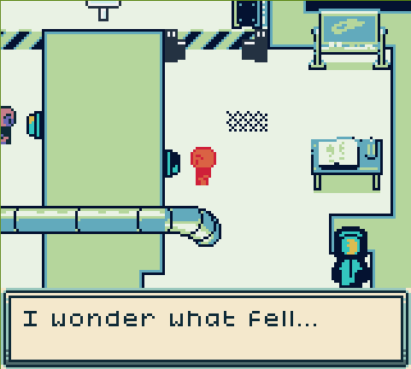

**Walkthrough:** Blue must first press the button on their side to open the right side gate, then Red needs to press their button so the crate drops on Blue’s side. Blue must then push the crate into the pipe so it travels to the other side. Once it’s on Red’s side, Red must push the crate to the cracks to open the gate to leave. Game over